**Reports**

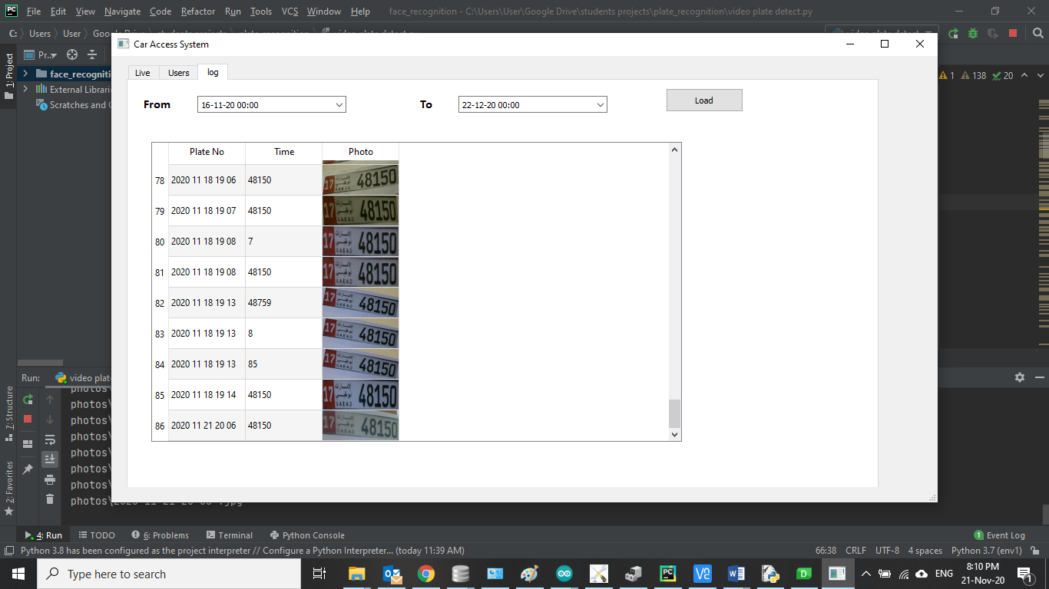

**The code to generate report**

def loadLog(self):  
 format = "yyyy MM dd hh mm";  
 print(self.fromTime.dateTime().toString(format))  
 db = sqlite3.connect('plateRecogDB.db')  
 cursor = db  
 command = '''SELECT * FROM log WHERE time BETWEEN ? AND ? '''  
 row= (self.fromTime.dateTime().toString(format),self.toTime.dateTime().toString(format))  
 result = cursor.execute(command,row)  
  
 ### to Fill table with result  
 self.table.setRowCount(0)  
 for row_number, row_data in enumerate(result):  
 self.table.insertRow(row_number)  
 for column_number, data in enumerate(row_data):  
 if(column_number==2):  
 item=self.getImageLable(data)  
 self.table.setCellWidget(row_number,column_number,item)  
 else :  
 self.table.setItem(row_number, column_number, QTableWidgetItem(str(data)))  
 self.table.verticalHeader().setDefaultSectionSize(40)  
  
def getImageLable(self,imName):  
 imageLabel =QtWidgets.QLabel(self.log)  
 imageLabel.setText("aa")  
 imageLabel.setScaledContents(True)  
 #pixmap = QtGui.QPixmap("2020 11 16 17 26 04.jpg")  
 imagename =str("photos\{0}.jpg".format(str(imName)))  
 print(imagename)  
  
 pixmap = QtGui.QPixmap(str("photos\{0}.jpg".format(imName)))  
  
 #pixmap.loadFromData(image,'jpg')  
 imageLabel.setPixmap(pixmap)  
 return imageLabel